CMOS DUAL COMPLEMENTARY PAIR PLUS INVERTER

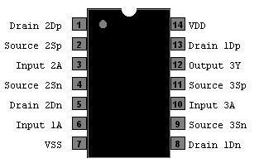

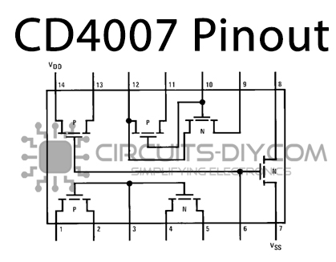

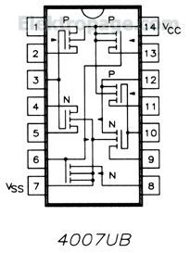

<https://wiki.analog.com/university/courses/electronics/electronics-lab-28>

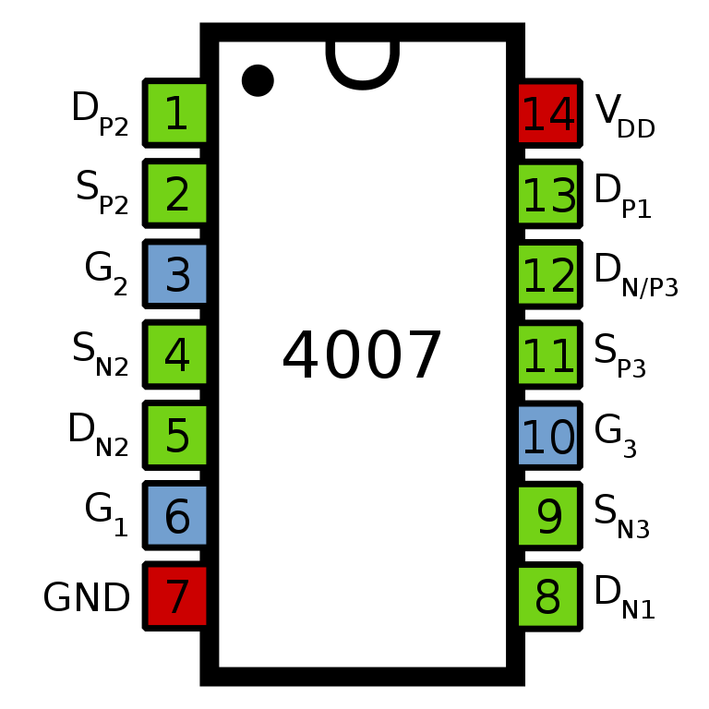

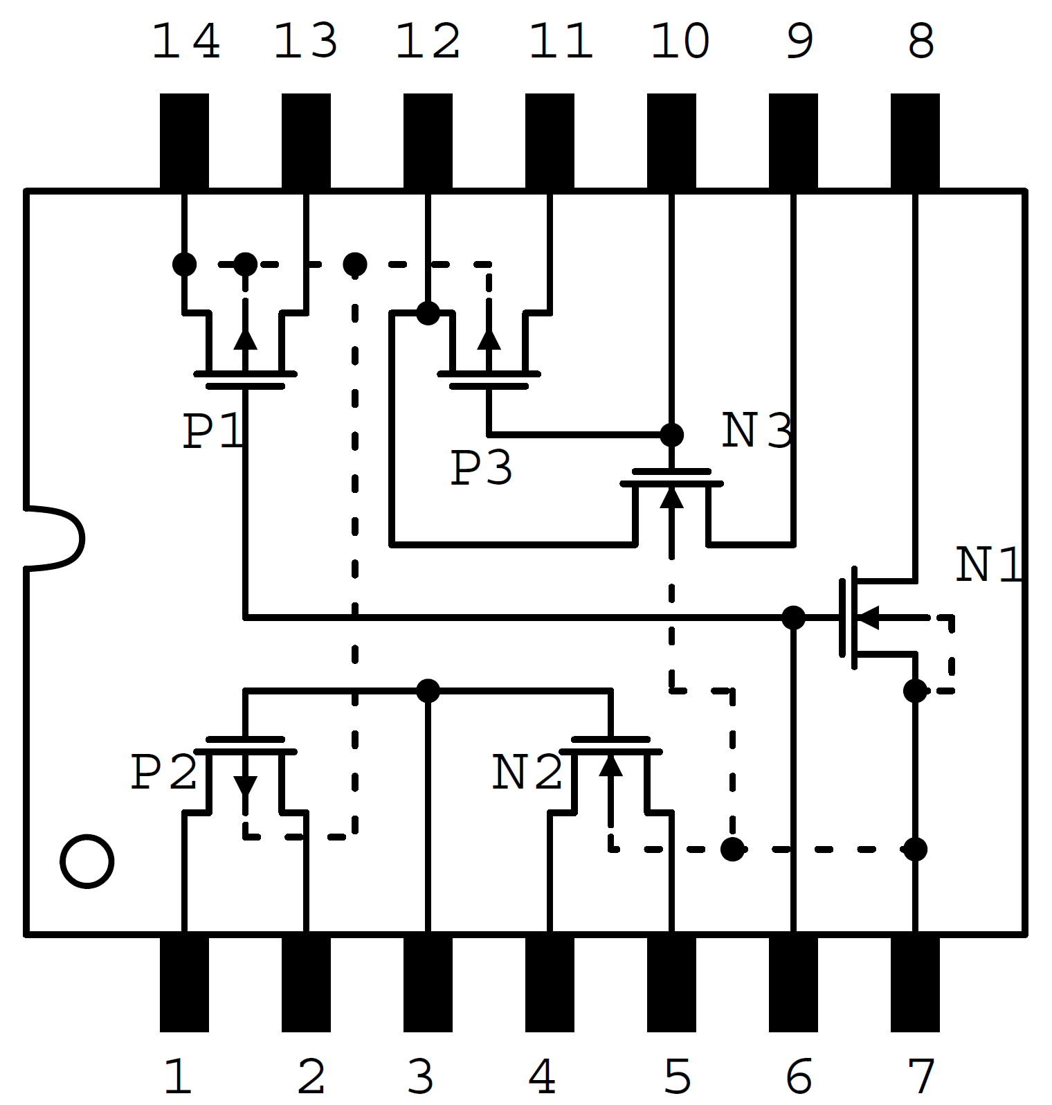

Code Pascal:-

for 4007:-

1, 5 , 8 , 12 ,13 out

8- Always 0

2,4,11 == 5v or vcc

9 == gnd

3, 6 , 10 input

equations:-

1 = !3

5 = 3

8 =0

12 =!10

13 = !6

